**THE GLOBALIZATION OF AMERICAN BANKING, 1962-1981**

Prior to 1960, only a handful of American commercial banks had any foreign operations. During the next 20 years, American banking became globalized; nearly every major bank established or expanded its overseas operations.

Decisions to grow overseas operations were influenced by macro-economic conditions such as the cost of capital, stage of the business cycle, and Federal monetary policy, as well as by the banks’ positions in interfirm social networks.

The overseas expansion of U.S. banking was largely complete by 1980, and since then commercial bank lending has declined substantially relative to foreign direct investment and cross-border portfolio flows. Once again, international banking is the domain of a small handful of U.S. banks.

Pre-1960s:

Limited international involvement by American commercial banks. Only a small number had any foreign operations.

1960s-1970s:

Significant expansion of American banking overseas. By 1980, 150 American banks had foreign branches spread across the globe.

During this period, large U.S. banks expanded their overseas presence, with nearly every major bank establishing or expanding their overseas operations.

1980s:

A substantial attenuation of the trend toward bank branch globalization. This period saw a contraction in overseas lending due to factors such as the Mexican debt crisis of 1982.

1980s-1990s:

Market-based forms of funding started to take over the core business of corporate lending for large banks, leading to a transition in the banking industry's focus.

Post-1980s:

Shift in the composition of capital flows, with market-based forms of funding increasingly taking precedence over bank lending.

Financial inclusion initiatives -

Financial inclusion refers to efforts to make financial products and services accessible and affordable to all individuals and businesses, regardless of their personal net worth or company size. Financial inclusion strives to remove the barriers that exclude people from participating in the financial sector and using these services to improve their lives. It is also called inclusive finance.

Financial inclusion is an effort to make every day financial services available to more of the world's population at a reasonable cost.

Financial inclusion may refer to geographical regions, consumers of a specific gender, consumers of a specific age, or other marginalized groups.

Financial inclusion may lead to greater overall innovation, economic growth, and consumer knowledge.

Advancements in fintech, such as digital transactions, are making financial inclusion easier to achieve.

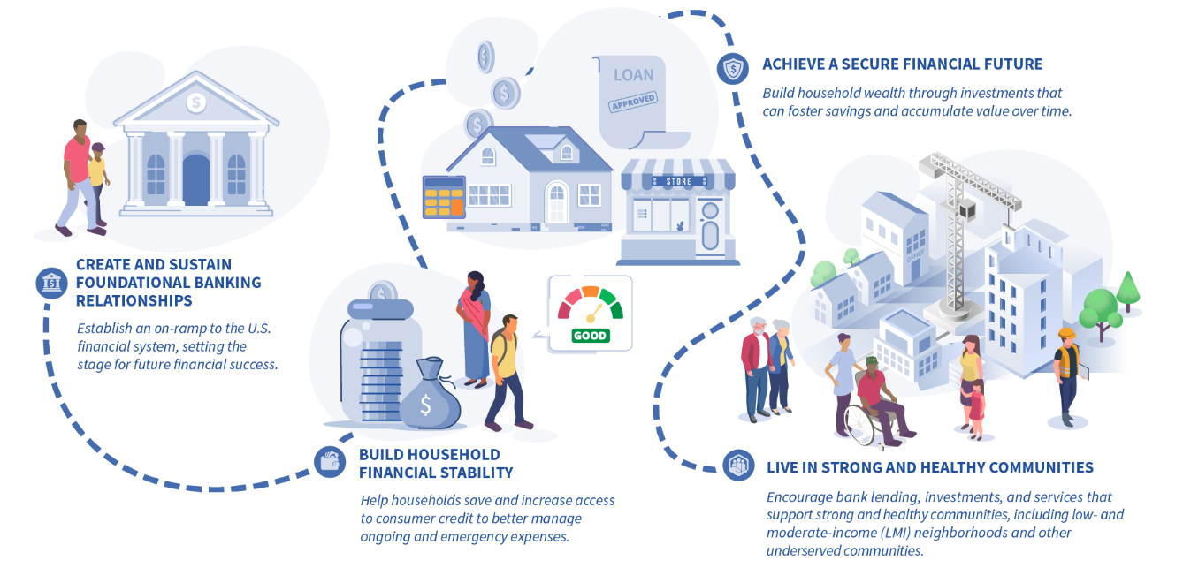

The FDIC promotes a state in which all U.S. households can establish, sustain, and benefit from banking relationships to create a strong financial foundation, manage their day-to-day finances, build wealth, and live in communities strengthened by bank lending, services, and investments.

**Importance of Financial Inclusion**

**Financial inclusion reduces poverty and inequality:** By empowering them with the tools to manage their finances and invest in income-generating activities, financial inclusion can help lift people out of poverty and reduce economic disparities.

**Financial inclusion promotes economic growth:** Increased financial inclusion leads to higher levels of savings, investment, and entrepreneurship, fostering economic growth and stability in both local communities and national economies.

**Financial inclusion promotes small businesses:** Small businesses often face challenges in accessing credit from traditional banking sources. Financial inclusion through innovative lending models and online platforms can provide much-needed funding for entrepreneurs to grow their businesses.

**Financial inclusion empowers otherwise marginalized demographics:** For example, financial inclusion initiatives targeted at women can promote gender equality and women's economic empowerment.

**Financial inclusion promotes innovation:** Financial inclusion drives innovation in the financial sector, leading to the development of new technologies and fintech solutions that cater to the needs of underserved populations.

**Financial inclusion may foster digital inclusion:** As technology plays a significant role in financial inclusion, promoting access to digital financial services also contributes to digital inclusion, ensuring that more people can participate in the digital economy.

**Challenges of Financial Inclusion**

There are perpetual and significant headwinds when striving for financial inclusion.

First, there is a major hurdle regarding a lack of awareness and knowledge about formal financial services. Rural and marginalized areas may simply not know what services or concepts exist, while some communities may have distrust in formal financial systems. Plus, cultural and social norms and traditions may influence financial behaviors and decisions.

Policy and [regulatory barriers](https://www.investopedia.com/articles/economics/09/financial-regulatory-body.asp) can deter financial institutions from serving low-income customers and entering underserved markets. Socioeconomic disparities and gender inequalities can hinder financial inclusion, with women and marginalized groups potentially facing greater barriers to access and control over financial resources.

It can be very difficult to solve a problem that can't be appropriately measured. Inadequate data and market information on unbanked and underbanked populations can hinder the development of targeted and effective financial inclusion strategies. In addition, geopolitical and conflict-related challenges can disrupt financial infrastructure and stability, further limiting access to financial services in specific physical regions.

Last, data privacy and security concerns may deter individuals from adopting digital financial services, especially in regions with inadequate data protection frameworks. In some cases, consumers may knowingly or unknowingly elect to financially exclude themselves based on the choices they decide. For example, those not trusting in digital services financially exclude themselves from many opportunities in exchange for greater control and comfort over their personal information.

**The Age of AI**

A quarter of a century ago, banking stood on the verge of the Digital Age. The internet was starting to reveal its potential and most bankers had a strong premonition that far-reaching change was coming. Today we feel a similar sense of awe as we contemplate the potential of gen AI, especially when powered by the cloud and rapidly expanding data capabilities.

**10 trends will change banking in 2024**

1. The rise of gen AI

Banks are likely to benefit more than other industries—our analysis indicates productivity could rise by 20–30% and revenue by 6%. Banks will need to not only utilize cloud and data effectively, but also to rethink work and talent.

2. Capturing the digital dividend

While most banks have mastered digital, it has come at the cost of close customer relationships. Banks will need to focus on finding ways to have meaningful conversations with customers across these channels – AI may hold the key.

3. All the risk we cannot see

In 2024, banks will be confronted by a variety of risks—some familiar, others less obvious. We've identified five that deserve particular attention. Planning for the unplanned will pay dividends.

4. A whole new way of working

Banks are realizing that people are just as important as technology to the success of their human + machine initiatives. They’re putting talent at the center of their strategies as they reimagine the future of work.

5. The power of pricing

Banks have always known optimized pricing can hugely impact their top and bottom lines. Now they’re starting to combine intuition with gen AI and more comprehensive data to turbocharge scenario planning and move closer to personalized pricing.

6. Time to think cloud first

Most banks’ early experiences of cloud were like that of a novice driver put behind the wheel of a Ferrari: they tried to drive it like a family sedan. Lately they're moving up through the gears and discovering what cloud can really do for them.

7. Regulation recalibrated

Bank regulations have ballooned since the 2008/9 Financial Crisis. We expect more collaboration among banks, central banks and regulators to work more effectively together.

8. From technology to engineering

How does the role of technology in banking evolve? A subtle change, with major organizational implications: the shift from a technology management to an engineering mindset.

9. The key to the core

New approaches and technologies—not least of which is gen AI and its ability to swiftly convert outdated code—are combining to finally free banks from the limitations of their aging core systems.

10. Beyond Six Sigma

Banks have historically employed re-engineering and cost-out thinking to optimize operations and experiences—the limitations were clear. Gen AI’s learning ability breaks this barrier and ushers in a new way of thinking that goes beyond Six Sigma. A screenshot of a computer screen
